
2013 NEW PRODUCTS

BAGS
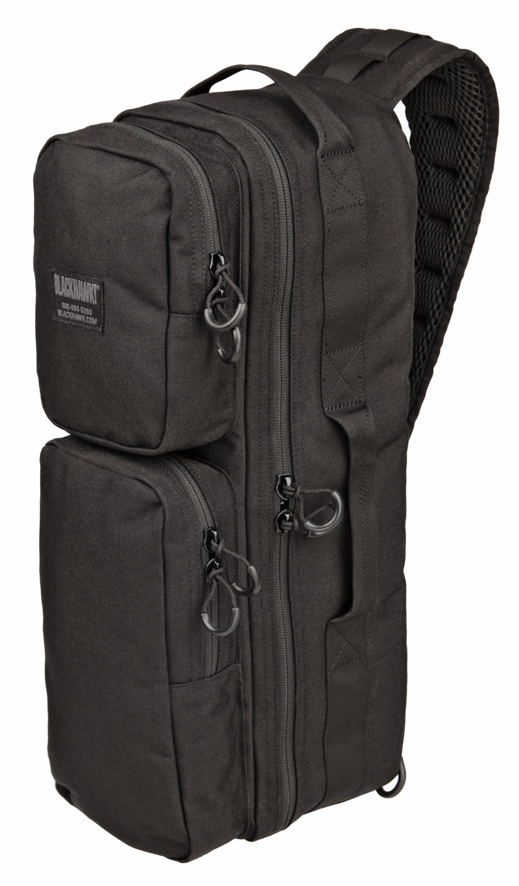
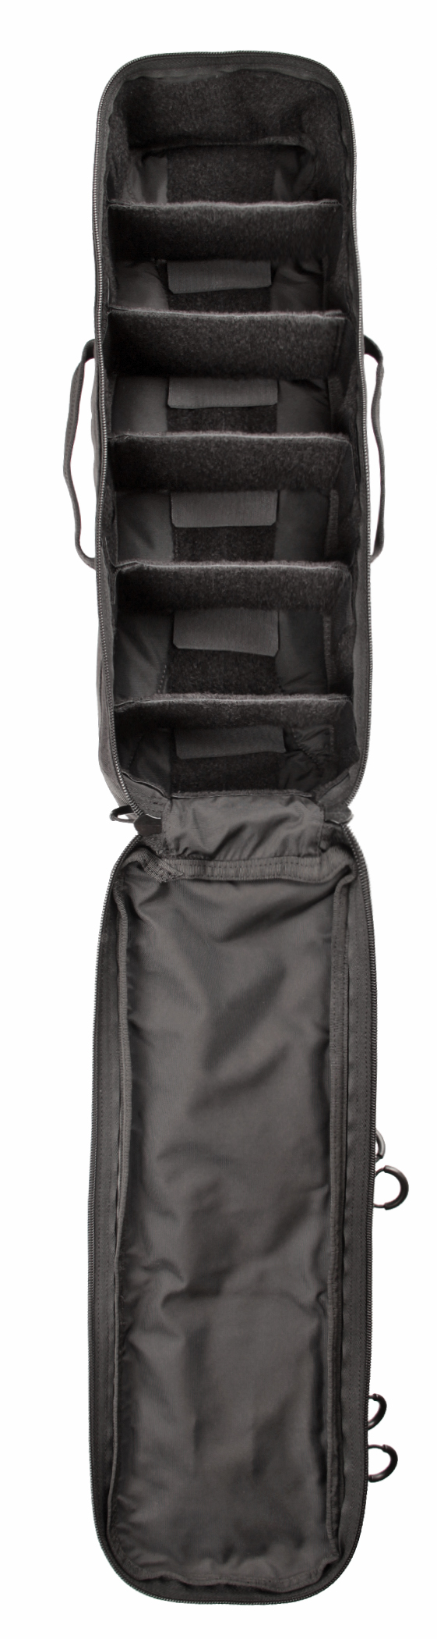
BLACKHAWK!® BRICK GO BAG
This low-profile “go bag” makes storing and transporting your gear a breeze. Its sling-style design allows you to rotate the bag forward for quick access to contents. When you’re done, just nudge the bag to your back again while it’s still slung over your shoulder

Features:
- Single padded shoulder strap for rapid “grab and go” capability
- Large loop-lined main compartment with adjustable dividers
- Two external pockets with internal elastic loops for small items

Part No. | Description | MSRP | Color | UPC
22GB03BK | Brick Go Bag BK | $99.99 | Black | 648018184321
22GB03CT | Brick Go Bag CT | $99.99 | Coyote Tan | 648018184338
22GB03FG | Brick Go Bag FG | $99.99 | Foliage Green | 648018184345
22GB03OD | Brick Go Bag OD | $99.99 | Olive Drab | 648018184369
22GB03RGCT | Brick Go Bag 2-tone RG/CT | $99.99 | Ranger Green/CT | 648018184376

